MADE BY SHARON MISHRA
Design Document for Artisan and User App
FIGMA LINK :-https://www.figma.com/design/GlgDQnRDAuHSUqkJMvb6to/Untitled?node-id=0-1&t=uQZ2KBk4C2mQPmvl-1

1. Application Overview
The app connects artisans and users (customers) to facilitate service bookings. Artisans
manage their profiles, bookings, and interactions with users. Users can browse artisan
profiles, view charges, and book services.
Dual Flow Structure
Upper Flow: For artisans (top row of the design).
Lower Flow For users (bottom row of the design).
User Registration: Simplified with Google Sign-Up only.

2. Screen Flow and Features
Artisan Flow (Upper Flow)
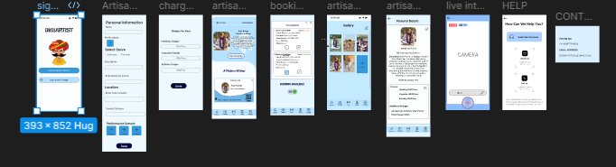
Artisan Sign-Up
Artisans provide service details, including genre, location, and performance samples. They
register by filling forms and uploading portfolio media.
Artisan Dashboard
A control center displaying bookings, charges, and access to profile editing and gallery management.
Key Features:
- Update Profile
- Manage Bookings
- Navigate to Gallery and Live Sessions
Artisan Profile
A detailed profile showcasing artisan services, skills, location, and portfolio. This is editable
by artisans and viewable by users.
Gallery
Displays uploaded images or videos of the artisan's work for users to view. Artisans can
manage media to highlight their expertise.
Live Interaction
Allows artisans to host live sessions to promote services or interact with users in real time.
Help & Contact (Artisan)
Support for artisans to address profile or app issues. Includes FAQs, contact support (email
or phone), and chat assistance.

User Flow (Lower Flow)
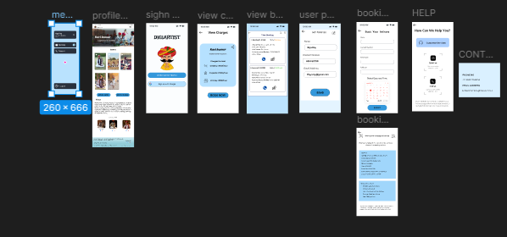

Google Sign-Up
Simplifies registration for users. Users sign up with a Google account and are redirected to
the home screen.
Home Screen
Central navigation for users with options to:
Check service pricing before booking. . Select and schedule a service.
view charges, and book services.
View Charges
Allows users to check pricing details before proceeding to book a service. Helps users make
informed decisions.
Book a Service
Users can schedule services with artisans by selecting service type, date, and time, and
entering details.
View Bookings
Displays current and past bookings with status updates (confirmed, pending, etc.).
Help & Contact (User)
Provides users with support for booking or app-related queries. Includes FAQs, chat
support, and direct contact options.
3. Color Scheme
Primary Colors
1. Light Blue (#B6E1FF):
- Background for screens and side menu bar.
- Purpose: Calm and inviting tone for both artisans and users.
2. White (#FFFFFF):
- Background for forms, cards, and input fields.
- Purpose: Clean and modern for high readability.
Secondary Colors
1.Dark Blue (#00008B):
- Button backgrounds (e.g., Save, Book Now).
- Purpose: Highlights important actions.
2. Gray (#A9A9A9):
- Text for secondary content (e.g., placeholder text).
- Purpose: Ensures subtle, non-distracting details.Accent Colors
4. Design Rationale
Artisan Flow Design Choices
Goal: Provide artisans with tools to manage profiles and bookings efficiently.
Why: To empower artisans to market their services effectively and build trust with users.
User Flow Design Choices
Goal: Enable users to discover, evaluate, and book artisans with ease.
Why: Users require a seamless process for service discovery and booking to ensure
satisfaction.

